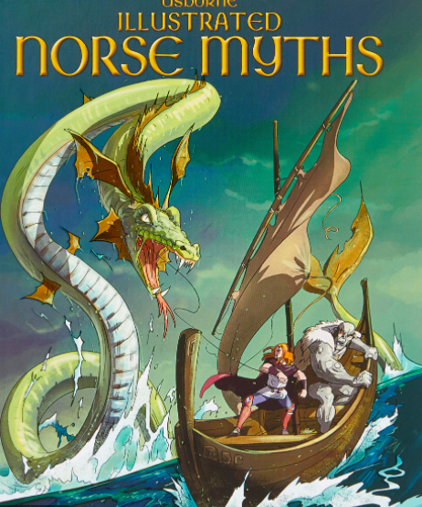

**PE**

We will be doing Hockey outdoors on a Thursday and gymnastics indoors on a Friday.

**PSHE**

Our theme this term will be ‘Me and My Relationships’, where children will be focusing upon communication and appropriate behaviour within friendships.

**COMPUTING**

Children will be looking at coding and computational thinking. We will identify how to use functions and inputs in order to create an interactive game.

**ART**

In art, children will look at tone, shadows and patterns when developing and designing their own figureheads for Viking longboats. Children will then use these designs to sculpt their figureheads out of clay.

**HISTORY**

Children will develop a chronologically secure knowledge and understanding of British, local and world history, establishing clear narratives about the Vikings.

They will construct informed responses that involve thoughtful selection and organisation of relevant historical information, noting connections, contrasts and trends over time.

**Year 6**

**Autumn 1 2025**

**Vikings**

**ENGLISH**

With SATs ahead, we will be revising all aspects of spelling, grammar and punctuation. In addition, we will consider how to answer three-point questions in reading comprehension.

Children will have the opportunity to write a narrative and recount in a variety of formats linked to ‘Norse Myths’ by Alex Frith and ‘Odd and the Frost Giants’ by Neal Gaiman.

**RE**

Children will be focusing on belonging – they will identify what it means to belong and relate this knowledge to the Islamic faith.

**MUSIC**

Listen 2 Me is currently providing ukulele lessons to pupils in Year 6.

**FRENCH**

In French, pupils will focus upon language relating to towns, directions and homes locations, and develop an understanding of how to ask where people located and describe their surroundings.

**MATHS**

Children will be solving addition and subtraction multi-step problems, deciding which operations and methods to use and explain why they were suitable. We will be multiplying numbers of up to 4 digits by a two-digit number and solving number and practical problems that involve ordering and comparing numbers to 10 000 000, rounding to a required degree of accuracy, using negative numbers and calculating intervals across zero.