English | Maths | Topic
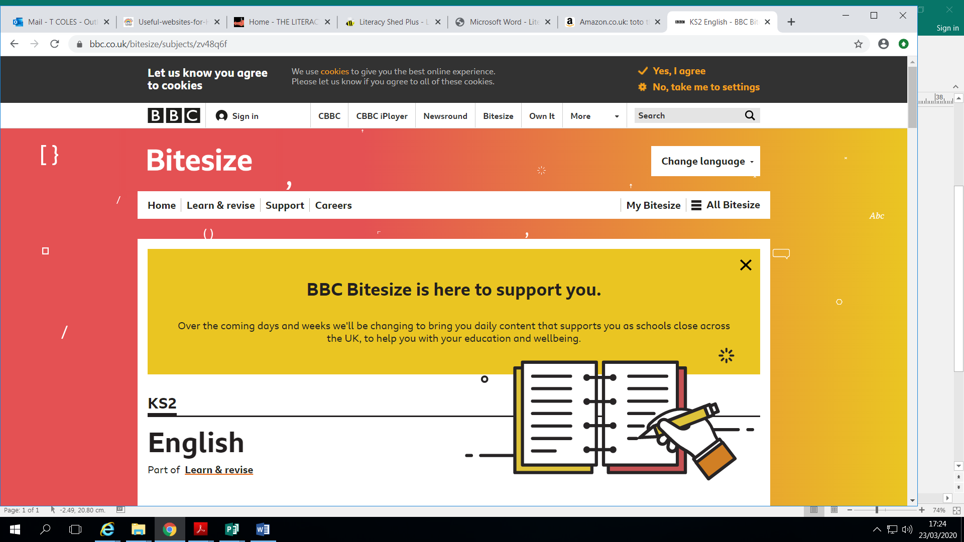  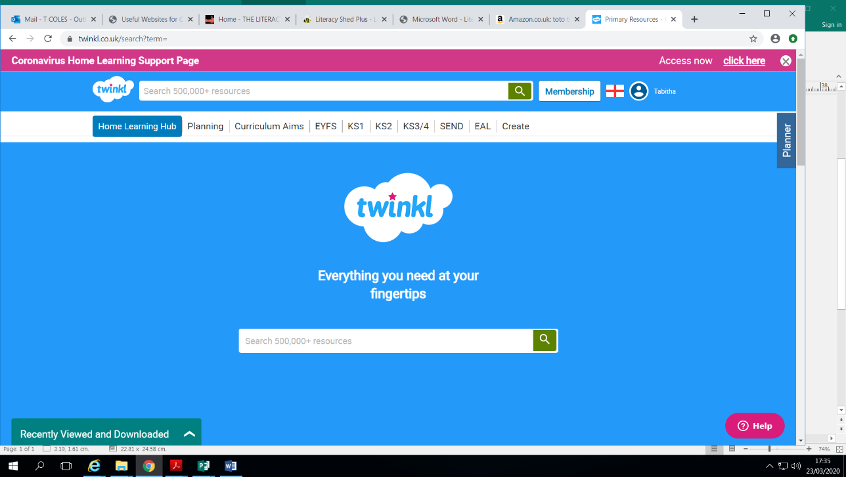  https://www.bbc.co.uk/bitesize/  This BBC website is full of lots of activities that supports your children’s learning. There are videos, games and reports that engage children of all ages. | https://www.twinkl.co.uk/  Website full of educational resources. A month’s free access will be given if school’s are closed, A code will be sent out if this happens. Setting up is really easy to do – go to www.twinkl.co.uk/ offer and enter the code UKTWINKLHELPS | https://www.twinkl.co.uk/  Website full of educational resources. A month’s free access will be given if school’s are closed, A code will be sent out if this happens. Setting up is really easy to do – go to www.twinkl.co.uk/ offer and enter the code UKTWINKLHELPS
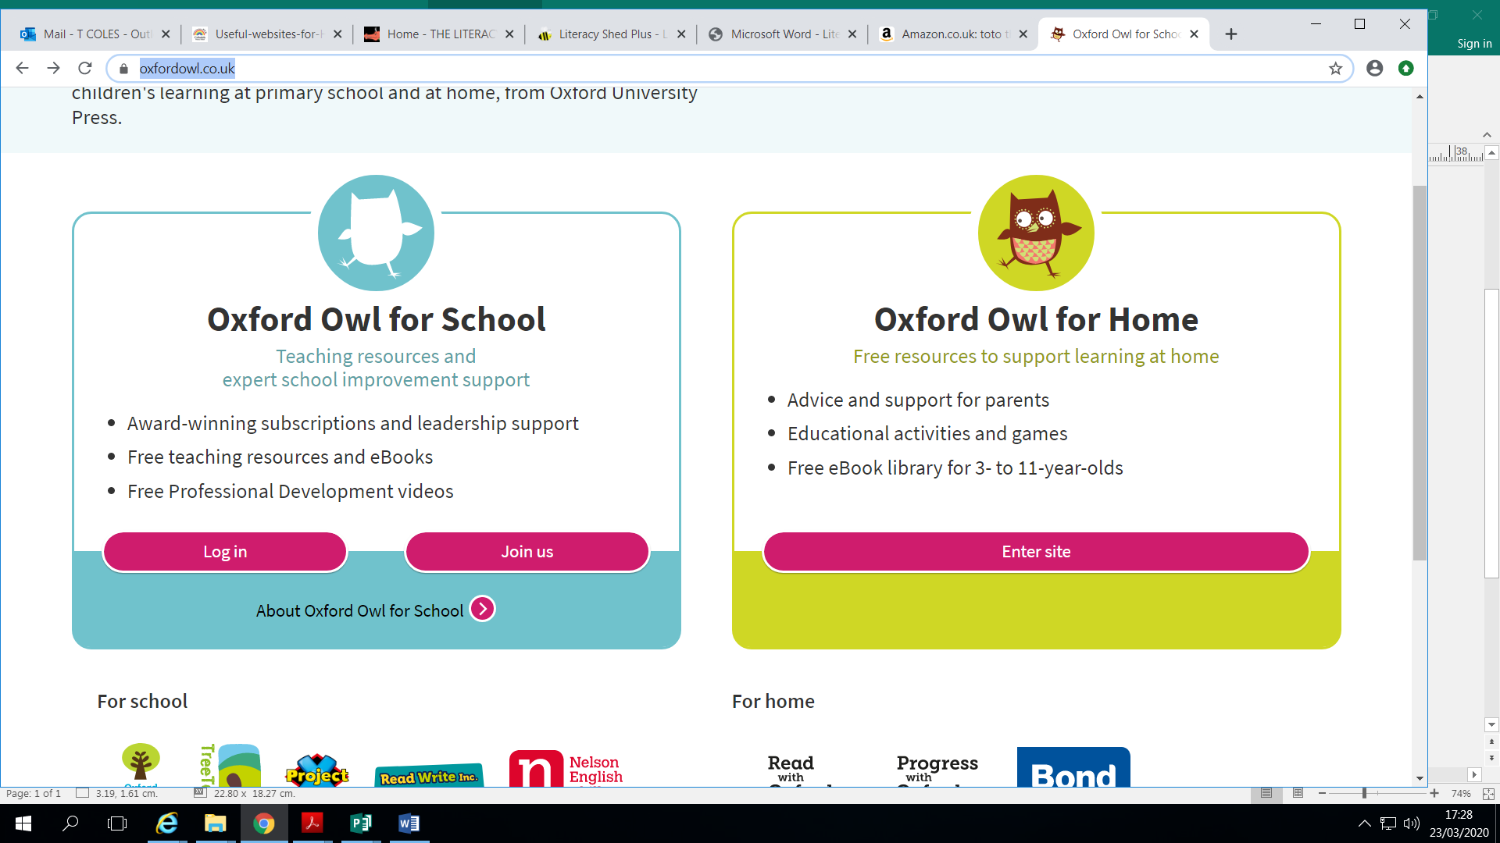  https://home.oxfordowl.co.uk/  Online reading books for children to read. | 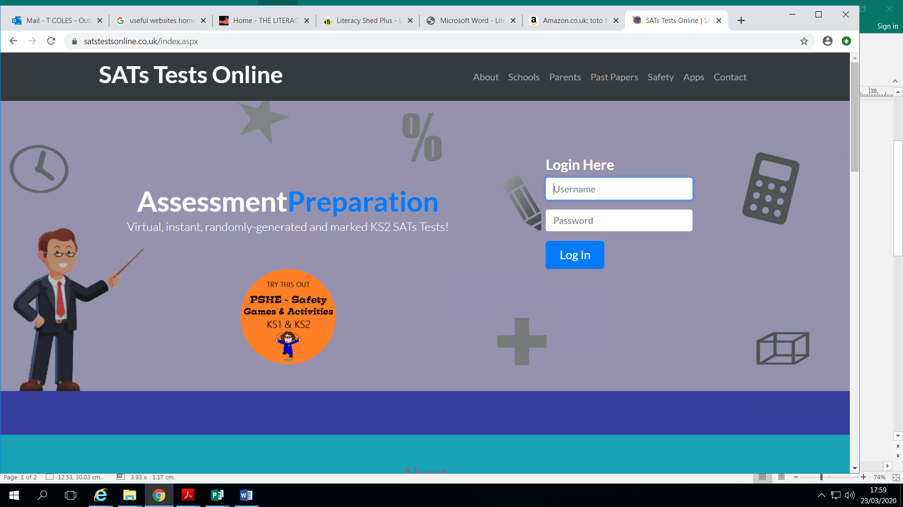  https://www.satstestsonline.co.uk/  Practice tests for Year 6 children. | 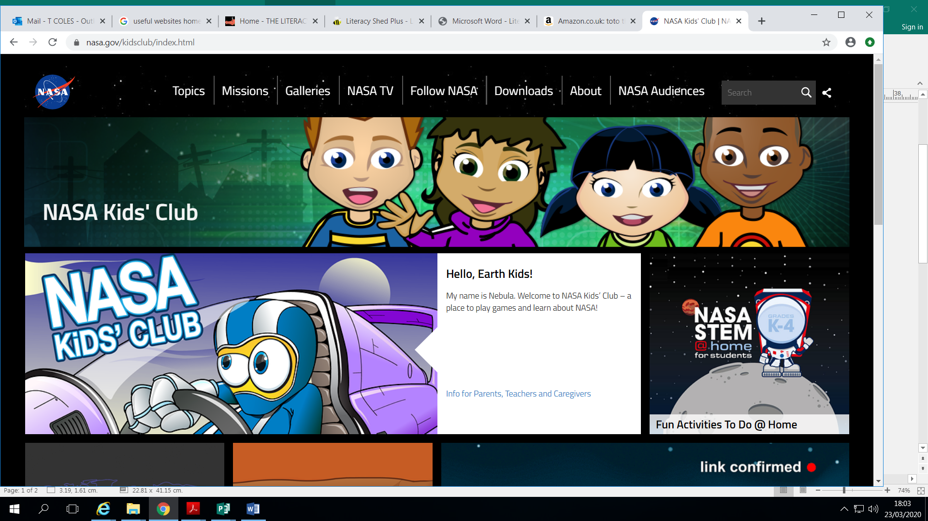  https://www.nasa.gov/kidsclub  Children’s website about all things space. Suitable for all.
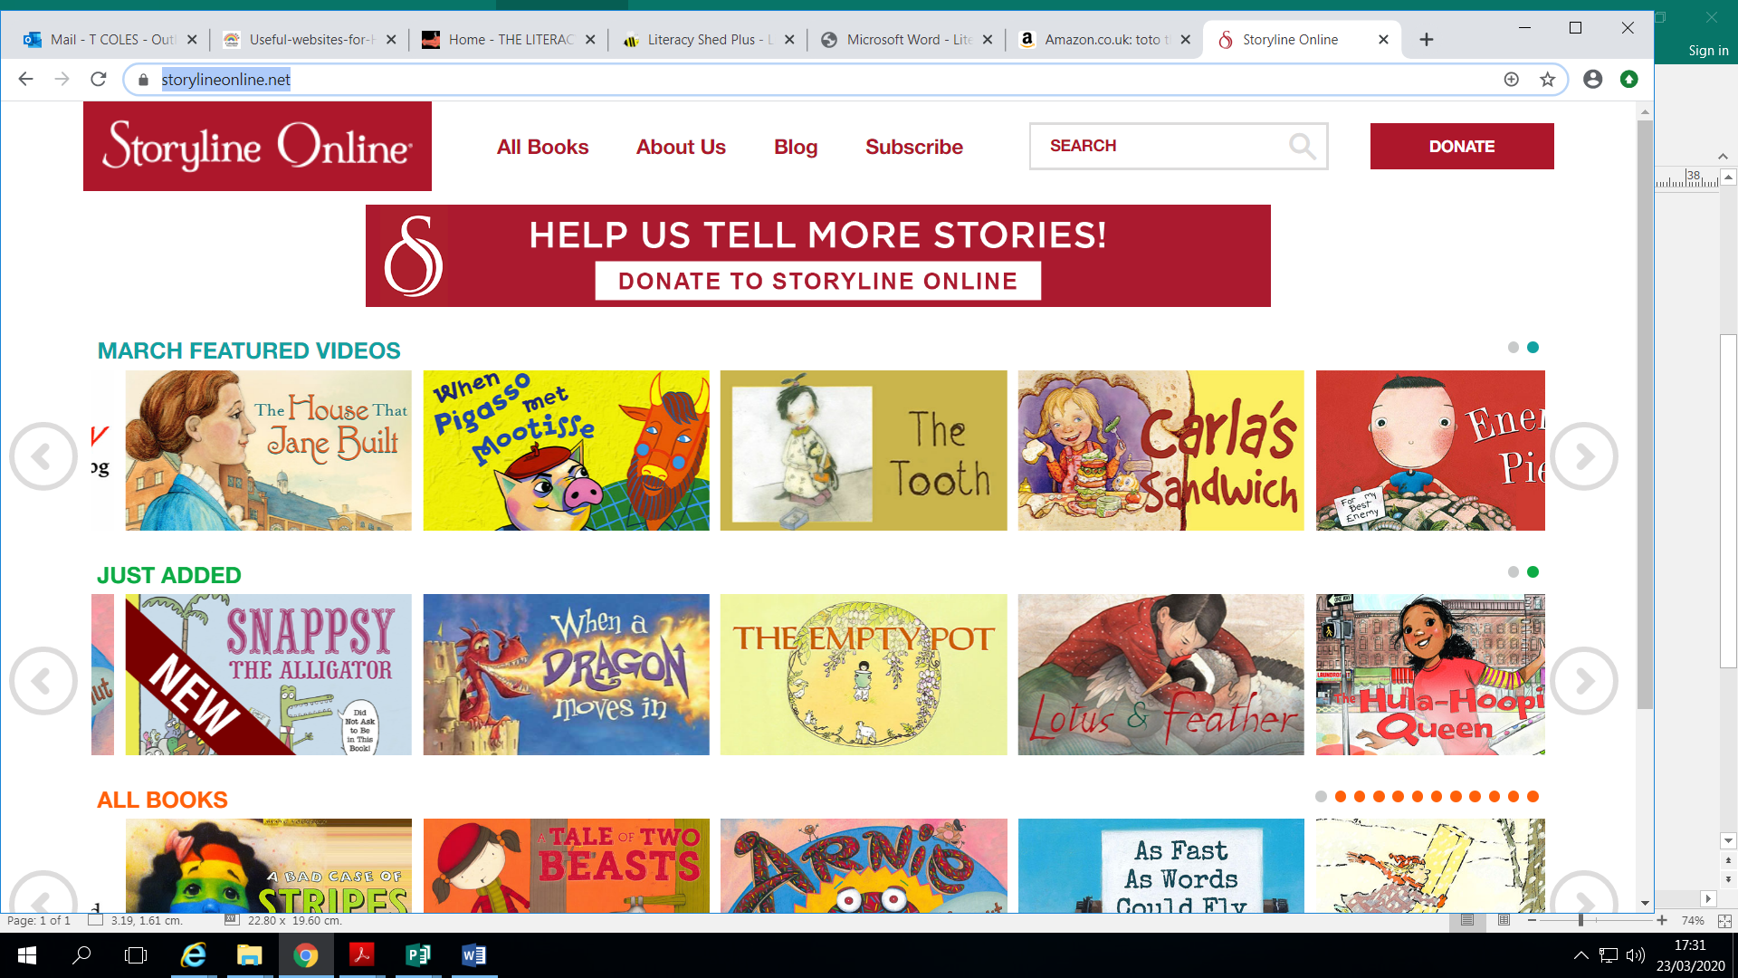  https://www.storylineonline.net/  Online stories read by various well known actors. Some stories have been animated. | 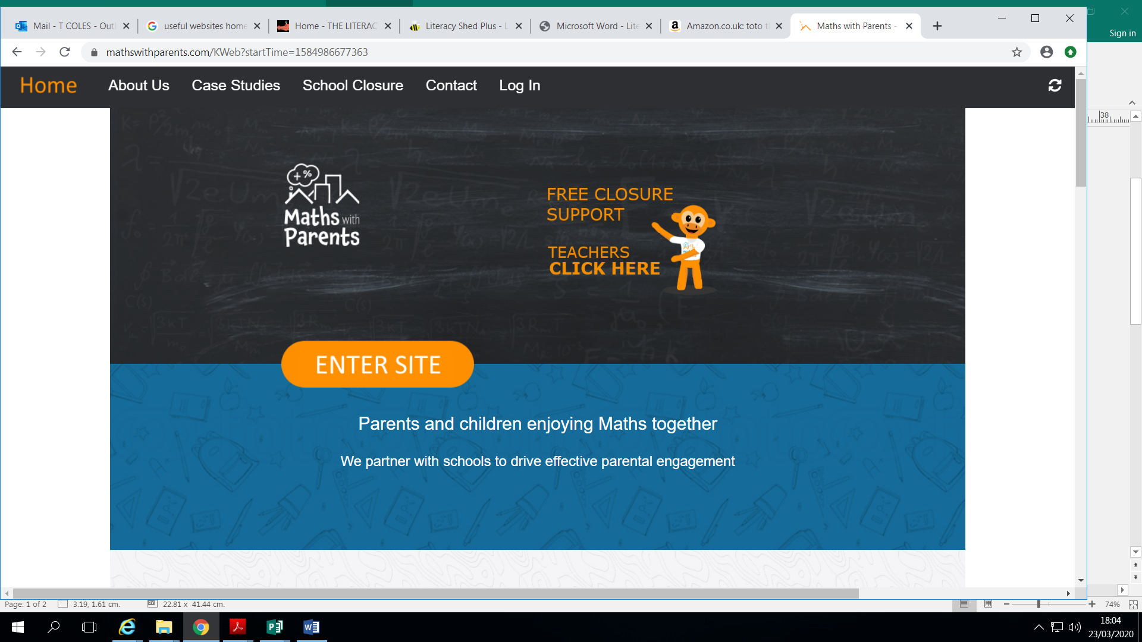  https://www.mathswithparents.com  This website is giving free access. | 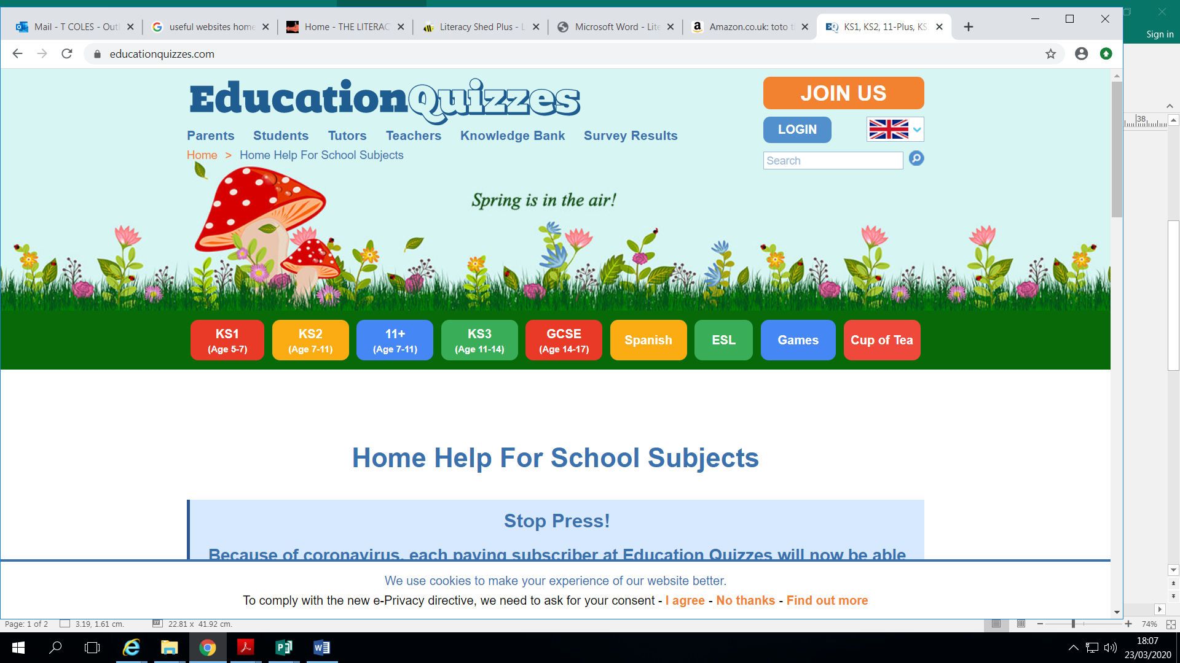  https://www.educationquizzes.com/  Education quizzes on different subjects.
https://www.twinkl.co.uk/  Website full of educational resources. A month’s free access will be given if school’s are closed, A code will be sent out if this happens. Setting up is really easy to do – go to www.twinkl.co.uk/ offer and enter the code UKTWINKLHELPS | 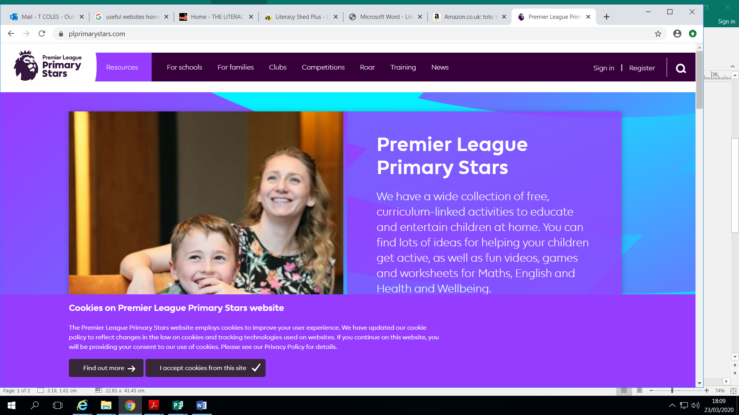  https://plprimarystars.com  Premier league primary stars. English maths sports and well being for 5 to 13 years olds. | 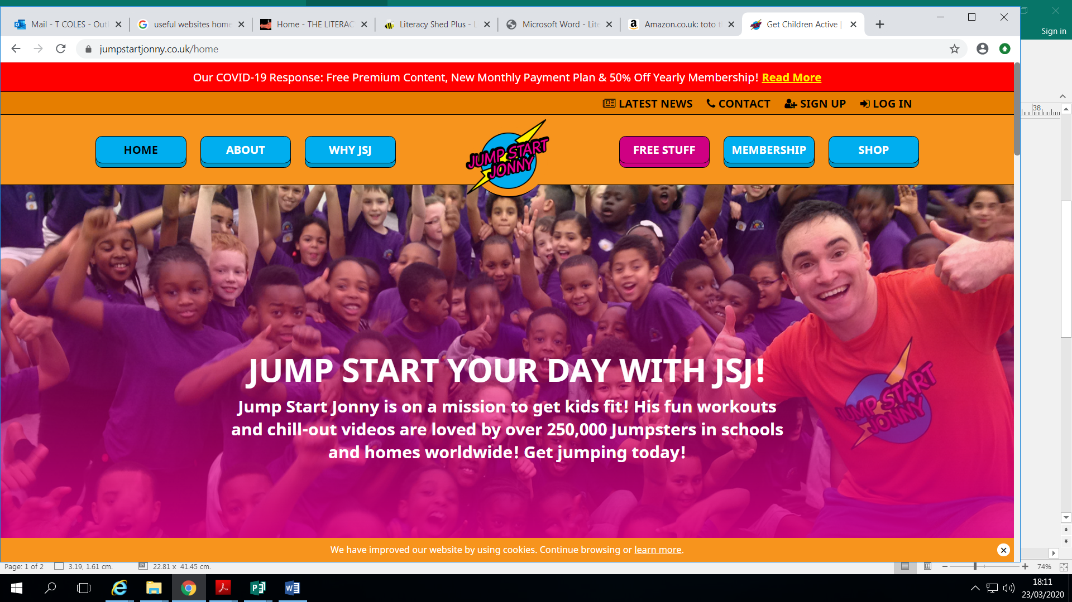  https://www.jumpstartjonny.co.uk/free-stuff  Physical Education for all Year Groups
https://www.satstestsonline.co.uk/  Practice tests for Year 6 children. | 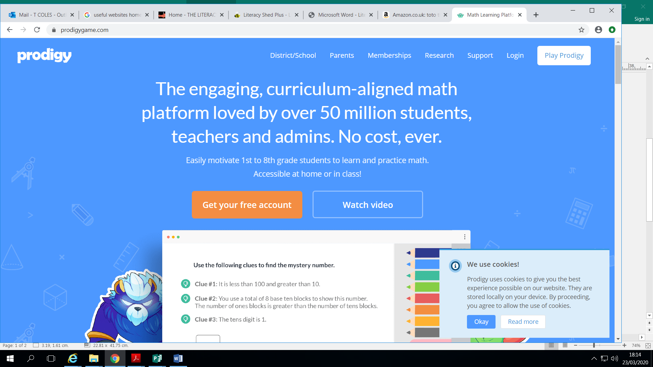  https://www.prodigygame.com/  Maths Game/Questions for all Year Groups | 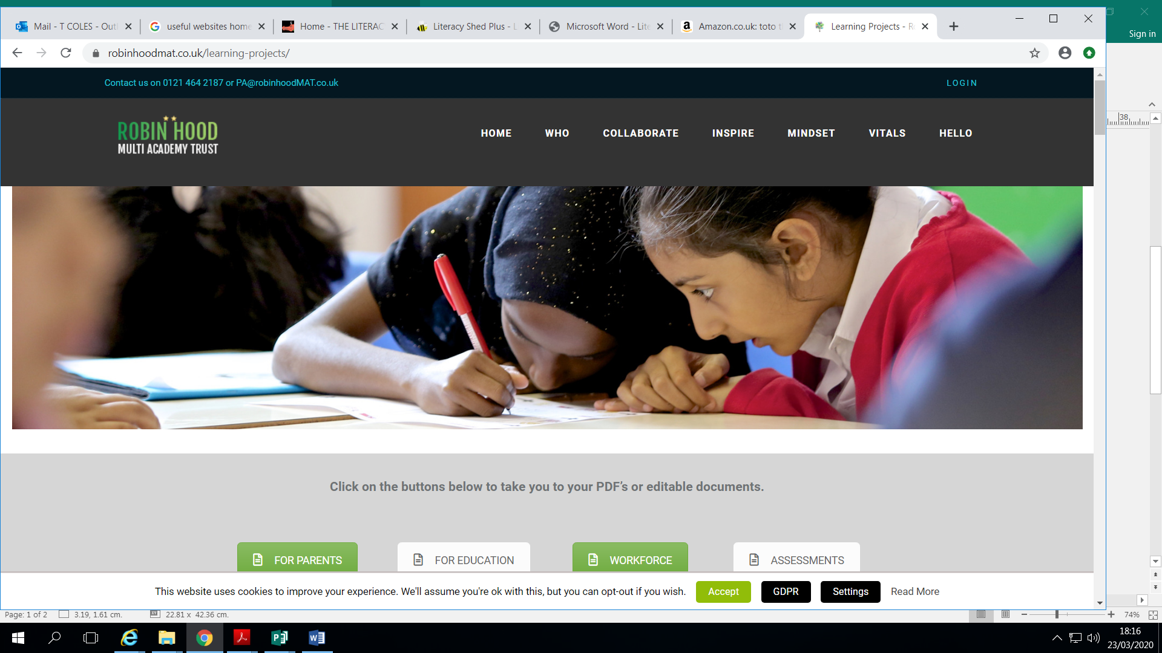  https://www.robinhoodmat.co.uk/wp-content/uploads/2020/03/Week-1-Learning-Project-Y5_6.pdf Work for Year 5 and Year 6
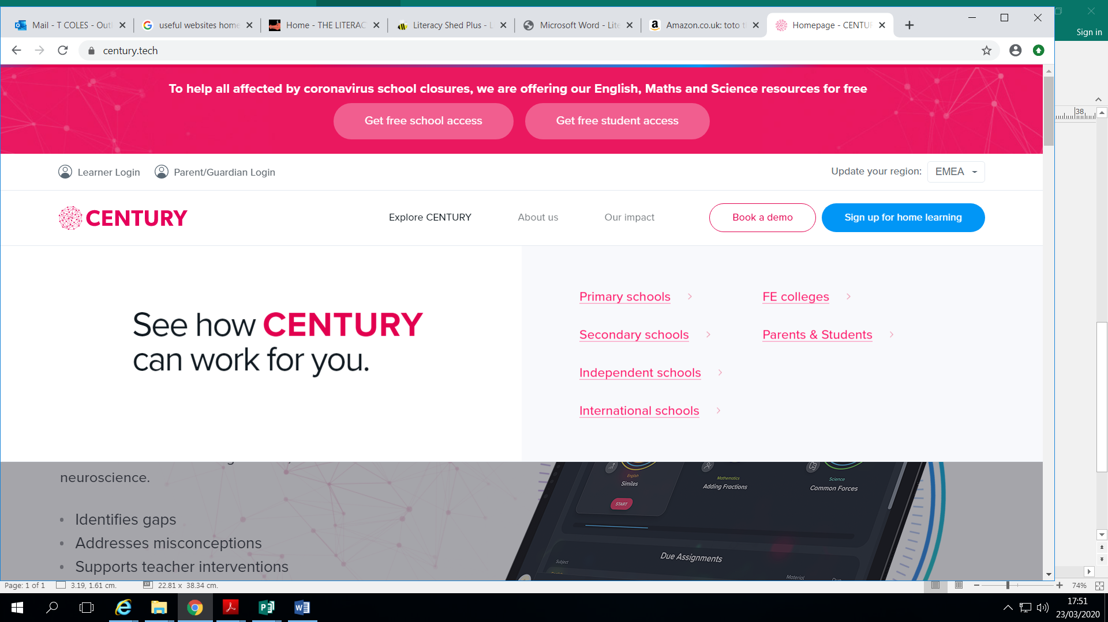  https://www.century.tech/  English, Maths and science tests designed to help children learn more quickly. Suitable for Years 3,4,5 and 6. free access. | 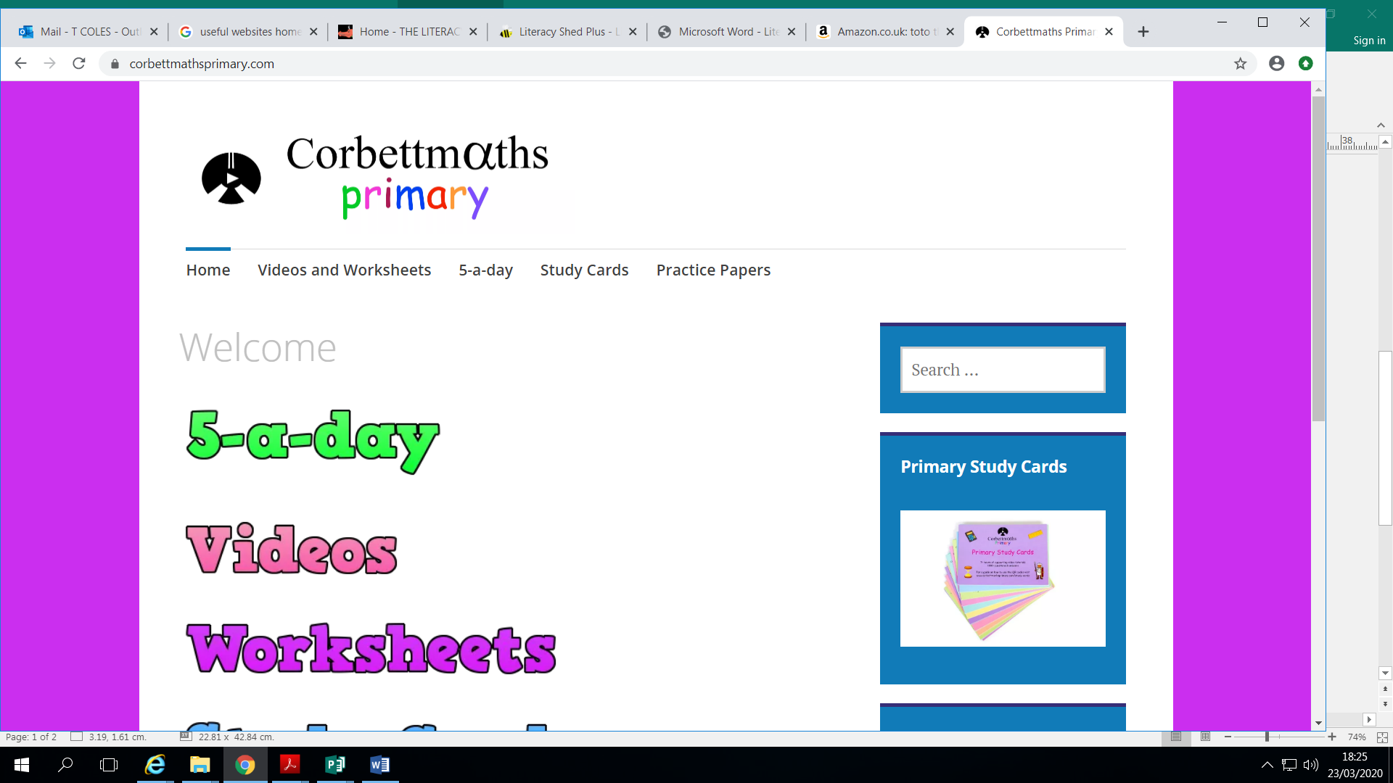  https://corbettmathsprimary.com/  Maths work for KS2. | https://www.century.tech/  English, Maths and science tests designed to help children learn more quickly. Suitable for Years 3,4,5 and 6. free access.
https://plprimarystars.com  Premier league primary stars. English maths sports and well being for 5 to 13 years olds. | 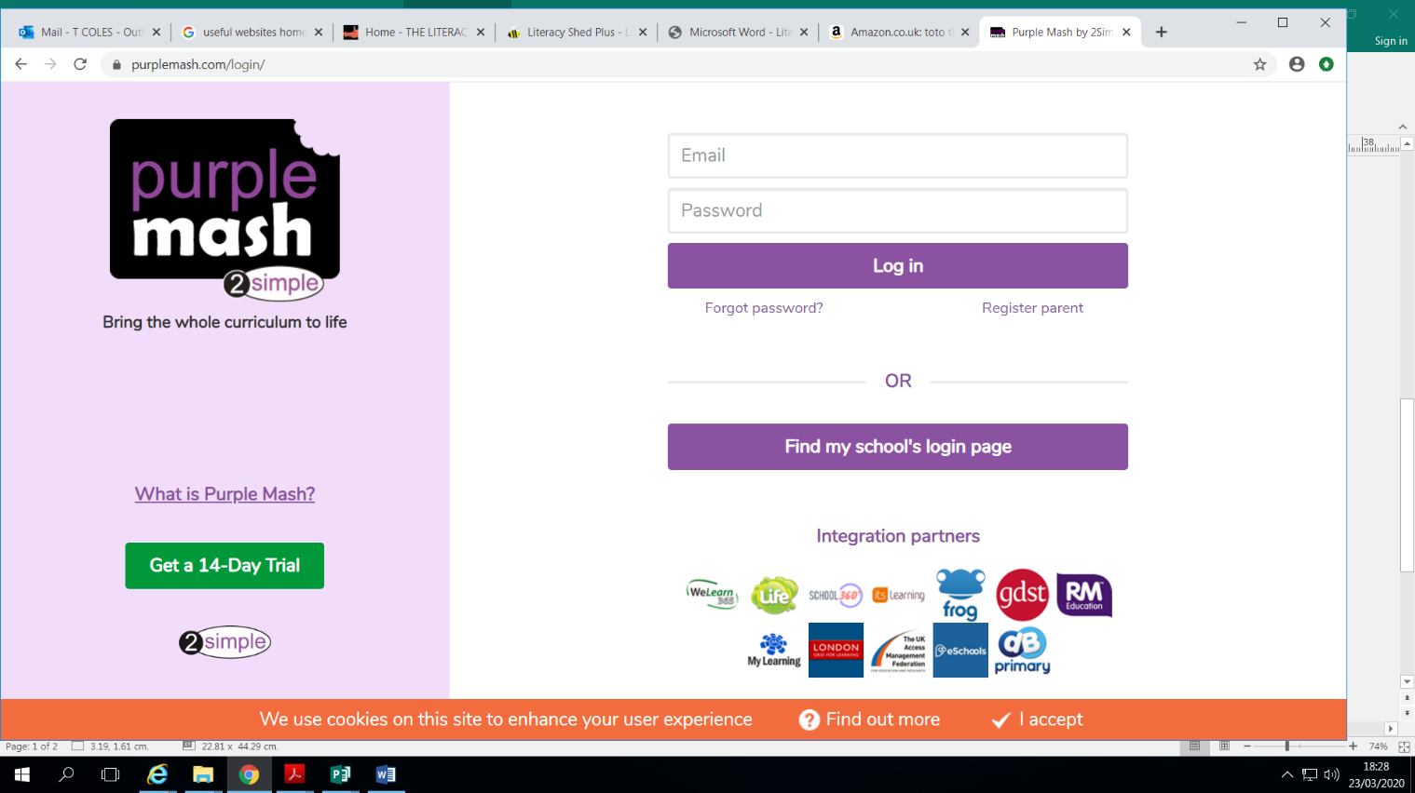  www.purplemash.com  Lots of educational games and coding. Suitable for Reception, Year 1, 2, 3, 4, 5 and 6. All children have a login. | 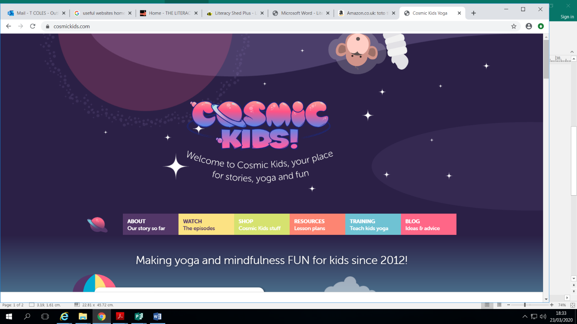  https://www.cosmickids.com/  Making yoga and mindfulness fun for kids since 2012. Free adventures on YouTube. Online kids yoga teacher training. Kids yoga DVDs. Kids yoga class plans.
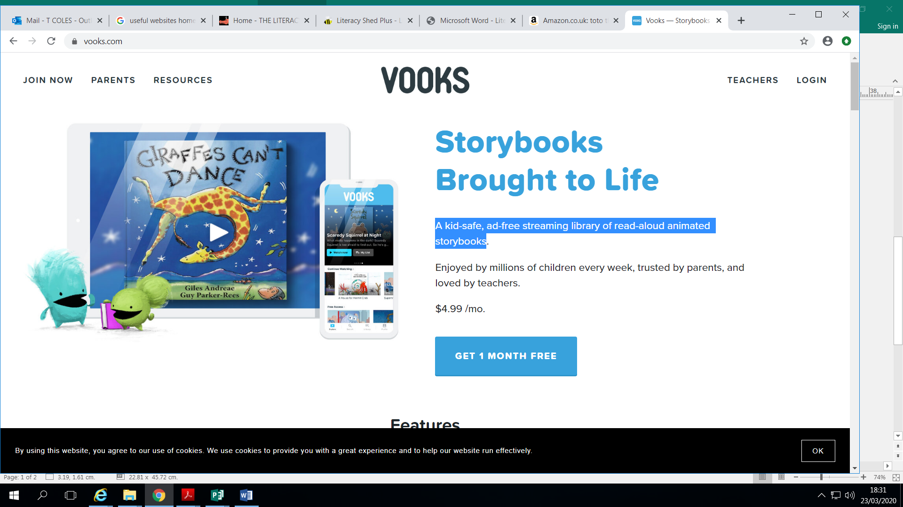  https://www.vooks.com/  A kid-safe, ad-free streaming library of read-aloud animated storybooks. Get one month free. | https://www.century.tech/  English, Maths and science tests designed to help children learn more quickly. Suitable for Years 3,4,5 and 6. free access.
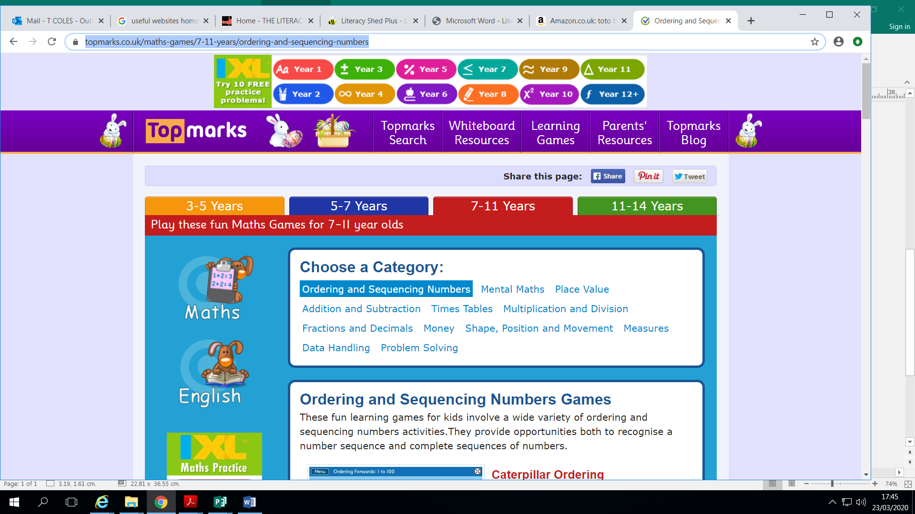

https://www.topmarks.co.uk/maths-games
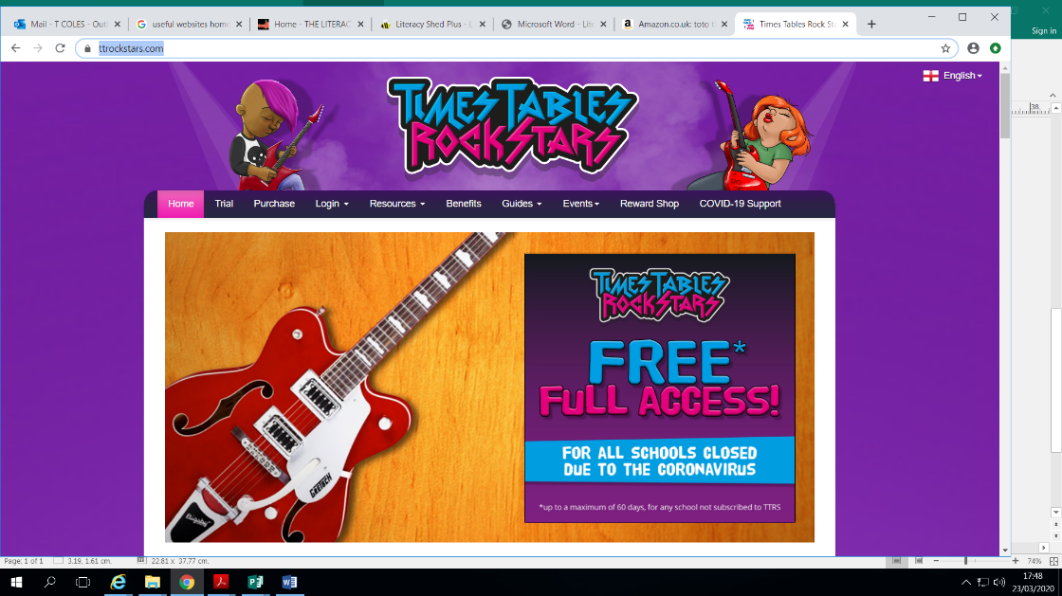
A mixture of games to support maths topics. Suitable for all levels.
https://ttrockstars.com/
Times tables competition. Free access.

