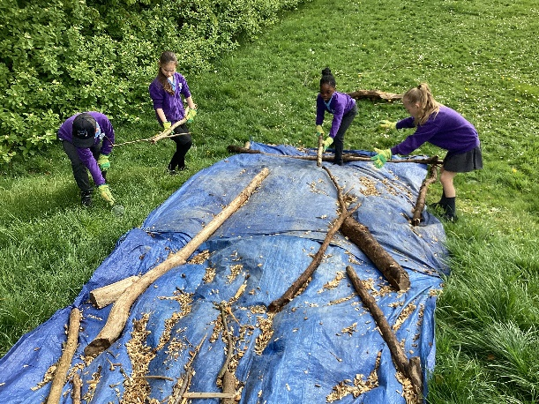 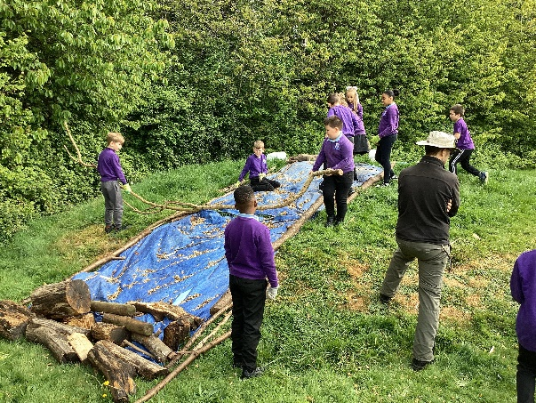

**24/04/25**

**I can recreate a river’s course**

**Forest School: recreated four different stages of the river’s story (from the text). Then, we poured water onto the start of our river in order to create the path of the river.**

